SARANA: A Programming Language Project Report
Serena Morris- 2208659, Raheem Gordon – 2208501, Chadrick Atkinson- 2204885, Akeem Creary - 2110275
University of Technology, Jamaica
CIT4004: Analysis of Programming Languages
Mr. David W. White
April 10, 2026

Table of Contents
1. Introduction 1
2. Paradigm, Level, and Purpose 1
2.1 Paradigm 1
2.2 High-Level vs Low-Level 2
2.3 General Purpose vs Domain Specific 2
3. Nine Characteristics of a Good Programming Language 2
3.1 Readability — Example 3
3.2 Writability — Example 3
3.3 Reliability — Example 3
3.4–3.9 Remaining Characteristics 3
4. Full Token List 4
5. Regular Expressions for Token Recognition 5
5.1 Keywords 5
5.2 Identifiers 6
5.3 Numeric Literals 6
5.4 String Literals 6
5.5 Operators 6
5.6 Delimiters 6
5.7 Comments and Whitespace 6
6. Formal Grammar (EBNF) 7
7. Parse Tree and Abstract Syntax Tree (AST) 8
7.1 Required Sample Program 8
7.2 Function with Conditional — Parse Tree 9
8. Scope and Binding 10
8.1 Scope Rules 10
8.2 Binding 10
8.3 Scope and Binding — Sample Code 10
9. Implementation Language 12
9.1 Why Python and PLY? 12
9.2 Compiler Pipeline 12
10. Error Handling 12
11. Complete Sample Programs 13
11.1 Required Assignment Sample 13
11.2 Functions and Loops 13
11.3 Boolean Logic and Short-Circuit Evaluation 14
12. LLM Integration and Comparison 14
12.1 Purpose of the Comparison 14
12.2 Expected Findings 14
13. Conclusion 15
References 16

1. Introduction
Sarana is a high-level, general-purpose, imperative programming language with a Caribbean and nature-inspired keyword set. It was designed and built as a group project for CIT4004 (Analysis of Programming Languages) at the University of Technology, Jamaica, Semester 2, 2025/2026.
The language draws its keyword vocabulary from Caribbean culture and natural imagery, words like bloom (declare), echo (print), cycle (loop), craft (define a function), and ketch (catch an exception). This design choice makes the language feel culturally grounded and highly readable while adhering to the formal requirements of a deterministic compiler.
Host link: https://python-sarana.streamlit.app

Property | Value
Language Name | Sarana
File Extension | .sa
Paradigm | Imperative / Procedural
Level | High-level
Purpose | General-purpose
Built With | Python 3 + PLY (Python Lex-Yacc)
Target Code | Compiles to Python
Inspiration | Caribbean / nature-inspired keyword set

2. Paradigm, Level, and Purpose

2.1 Paradigm
Sarana follows the imperative and procedural programming paradigms. In an imperative paradigm, programs consist of explicit sequences of statements that change program state step by step. In the procedural extension, those statements are organized into reusable functions (craft blocks), which can accept parameters, perform computations, and return values.
This means that a Sarana program reads from top to bottom, executing one statement at a time, assigning values to variables, evaluating expressions, calling functions, and handling exceptions exactly as a programmer would instruct a computer to behave.

2.2 High-Level vs Low-Level
Sarana is a high-level language. It abstracts away all machine-level concerns such as memory addresses, registers, and CPU instructions. The programmer works entirely with human-readable constructs: named variables, arithmetic expressions, functions, loops, and strings. Sarana source code is then compiled to Python, which in turn handles all low-level execution details.

2.3 General Purpose vs Domain Specific
Sarana is a general-purpose programming language. It is not tied to any single application domain; it can be used to write numeric computations, string processing programs, iterative algorithms, recursive functions, or exception-handling routines. The language's feature set (arithmetic, conditionals, loops, functions, arrays, booleans) supports a broad class of computational problems.

3. Nine Characteristics of a Good Programming Language
According to the principles studied in CIT4004, a good programming language must exhibit characteristics that support readability, writability, and reliability. The table below demonstrates how each of the nine characteristics is present in Sarana.
# | Characteristic | How Sarana Demonstrates It
1 | Readability | Natural English/Caribbean keywords (bloom, echo, cycle, ketch) make code self-documenting and easy to follow at a glance.
2 | Writability | Concise syntax — one keyword per concept, no boilerplate, no type declarations required for basic programs.
3 | Reliability | Static semantic analysis catches errors before execution; try/ketch exception handling prevents unhandled crashes at runtime.
4 | Simplicity | Small keyword set (14 keywords), consistent grammar rules, and a single way to perform each operation.
5 | Orthogonality | Constructs combine predictably; any expression can appear anywhere an expression is expected without special cases.
6 | Data Types | Supports Integer, Float, String, Boolean, and Array — each with clear, unambiguous literals and consistent behaviour.
7 | Syntax Design | Brace-delimited blocks { } and mandatory semicolons reduce parsing ambiguity and make block boundaries explicit.
8 | Support for Abstraction | craft functions enable procedural abstraction; local scope is strictly enforced, supporting information hiding.
9 | Exception Handling | try / ketch blocks allow programs to recover gracefully from runtime errors such as division by zero.

3.1 Readability — Example
The following Sarana code reads almost like English, demonstrating how Caribbean keywords improve readability:
bloom score = 85;
when (score >= 60) {
echo "Passed!";
} otherwise {
echo "Failed.";
}
Even a non-programmer can read this and understand the intent: declare a score of 85, and if it is at least 60, print Passed, otherwise print Failed.

3.2 Writability — Example
Sarana requires no type declarations, no class definitions, and no boilerplate. A programmer can begin writing logic immediately:
bloom A = 20;
bloom B = 40;
bloom C = A + B * B;
echo "The result is " C;

3.3 Reliability — Example
Sarana's semantic analyzer detects undeclared variables and type mismatches before execution. Additionally, runtime errors are caught by the try/ketch mechanism:
try {
bloom D = C / 0;
}
ketch {
echo "Error: Division by zero attempted but not allowed.";
}

3.4–3.9 Remaining Characteristics
Simplicity is demonstrated by the small, orthogonal keyword set of only 14 reserved words. Orthogonality is evident in that expressions can appear anywhere, as variable values, function arguments, loop conditions, or return values with no special cases. Data types are explicitly supported through integer, float, string, boolean, and array literals. Syntax design uses braces for block delimiting and semicolons as statement terminators, reducing ambiguity. Support for abstraction is provided through craft functions with local scope. Exception handling is built into the language core via try/ketch.

4. Full Token List
The following table lists every token recognized by the Sarana lexer, along with its regex pattern and usage examples.
Token Type | Regex Pattern / Description | Examples
BLOOM | Keyword bloom | bloom
ECHO | Keyword echo | echo
WHEN | Keyword when | when
OTHERWISE | Keyword otherwise | otherwise
CYCLE | Keyword cycle | cycle
CRAFT | Keyword craft | craft
RETURN | Keyword return | return
TRY | Keyword try | try
KETCH | Keyword ketch | ketch
TRUE | Keyword true | true
FALSE | Keyword false | false
AND | Keyword and | and
OR | Keyword or | or
NOT | Keyword not | not
IDENTIFIER | [a-zA-Z_][a-zA-Z0-9_]* | x, myVar, count
INTEGER | [0-9]+ | 42, 0, 1620
FLOAT | [0-9]+\.[0-9]+ | 3.14, 0.5
STRING | "..." or '...' | "hello", 'world'
PLUS | \+ | a + b
MINUS | \- | a - b
MULTIPLY | \* | a * b
DIVIDE | \/ | a / b
MODULO | \% | a % b
ASSIGN | = | bloom x = 5
DOUBLE_EQUALS | == | x == y
NOT_EQUALS | != | x != y
LESS_THAN | < | x < y
GREATER_THAN | > | x > y
LESS_EQUAL | <= | x <= y
GREATER_EQUAL | >= | x >= y
LPAREN | \( | function calls
RPAREN | \) | function calls
LBRACE | \{ | block start
RBRACE | \} | block end
LBRACKET | \[ | array start
RBRACKET | \] | array end
SEMICOLON | ; | statement terminator
COMMA | , | argument separator

5. Regular Expressions for Token Recognition
The PLY lexer uses the following regular expression rules to tokenize Sarana source code. Keywords are matched before identifiers by checking the token value against a reserved word dictionary.

5.1 Keywords
Keywords are recognized by first matching the IDENTIFIER pattern, then checking against the reserved words table:
reserved = {
'bloom':'BLOOM', 'echo':'ECHO', 'when':'WHEN',
'otherwise':'OTHERWISE', 'cycle':'CYCLE', 'craft':'CRAFT',
'return':'RETURN', 'try':'TRY', 'ketch':'KETCH',
'true':'TRUE', 'false':'FALSE',
'and':'AND', 'or':'OR', 'not':'NOT'
}

5.2 Identifiers
t_IDENTIFIER r'[a-zA-Z_][a-zA-Z0-9_]*'

5.3 Numeric Literals
t_FLOAT r'[0-9]+\.[0-9]+'
t_INTEGER r'[0-9]+'

5.4 String Literals
t_STRING r'"[^"]*"|' + r"'[^']*'"

5.5 Operators
t_PLUS r'\+'
t_MINUS r'\-'
t_MULTIPLY r'\*'
t_DIVIDE r'\/'
t_MODULO r'\%'
t_DOUBLE_EQUALS r'=='
t_NOT_EQUALS r'!='
t_LESS_EQUAL r'<='
t_GREATER_EQUAL r'>='
t_LESS_THAN r'<'
t_GREATER_THAN r'>'
t_ASSIGN r'='

5.6 Delimiters
t_LPAREN r'\('
t_RPAREN r'\)'
t_LBRACE r'\{'
t_RBRACE r'\}'
t_LBRACKET r'\['
t_RBRACKET r'\]'
t_SEMICOLON r';'
t_COMMA r','

5.7 Comments and Whitespace
t_ignore_COMMENT r'--[^\n]*'
t_ignore ' \t'

6. Formal Grammar (EBNF)
The grammar of Sarana is specified below in Extended Backus-Naur Form (EBNF). The grammar drives both the PLY parser and the construction of the Abstract Syntax Tree (AST).

program ::= statement* EOF

statement ::= bloom_stmt
| echo_stmt
| when_stmt
| cycle_stmt
| craft_stmt
| try_stmt
| return_stmt
| expression_stmt

bloom_stmt ::= 'bloom' IDENTIFIER '=' expression ';'
echo_stmt ::= 'echo' expression+ ';'
when_stmt ::= 'when' '(' expression ')' block else_tail
else_tail ::= 'otherwise' 'when' '(' expression ')' block else_tail
| 'otherwise' block
| ε
cycle_stmt ::= 'cycle' '(' expression ')' block
craft_stmt ::= 'craft' IDENTIFIER '(' params? ')' block
return_stmt ::= 'return' expression ';'
try_stmt ::= 'try' block 'ketch' block
block ::= '{' statement* '}'

expression ::= logic_or
logic_or ::= logic_and ( 'or' logic_and )*
logic_and ::= equality ( 'and' equality )*
equality ::= comparison ( ( '==' | '!=' ) comparison )*
comparison ::= term ( ( '<' | '>' | '<=' | '>=' ) term )*
term ::= factor ( ( '+' | '-' ) factor )*
factor ::= unary ( ( '*' | '/' | '%' ) unary )*
unary ::= ( 'not' | '-' ) unary | primary
primary ::= INTEGER | FLOAT | STRING | 'true' | 'false'
| IDENTIFIER
| IDENTIFIER '(' args? ')'
| '[' args? ']'
| '(' expression ')'

The grammar enforces PEMDAS/BODMAS operator precedence through the layered expression rules: logic_or is the lowest precedence, factor is the highest (apart from unary and primary). Parentheses override precedence via the primary rule.

7. Parse Tree and Abstract Syntax Tree (AST)
This section presents the parse tree for the required assignment sample program, followed by additional examples for conditional and function constructs.

7.1 Required Sample Program
Source code:
bloom A = 20;
bloom B = 40;
bloom C = A + B * B;
try {
bloom D = C / 0;
}
ketch {
echo "Error: Division by zero attempted but not allowed.";
}
echo "The result is " C;
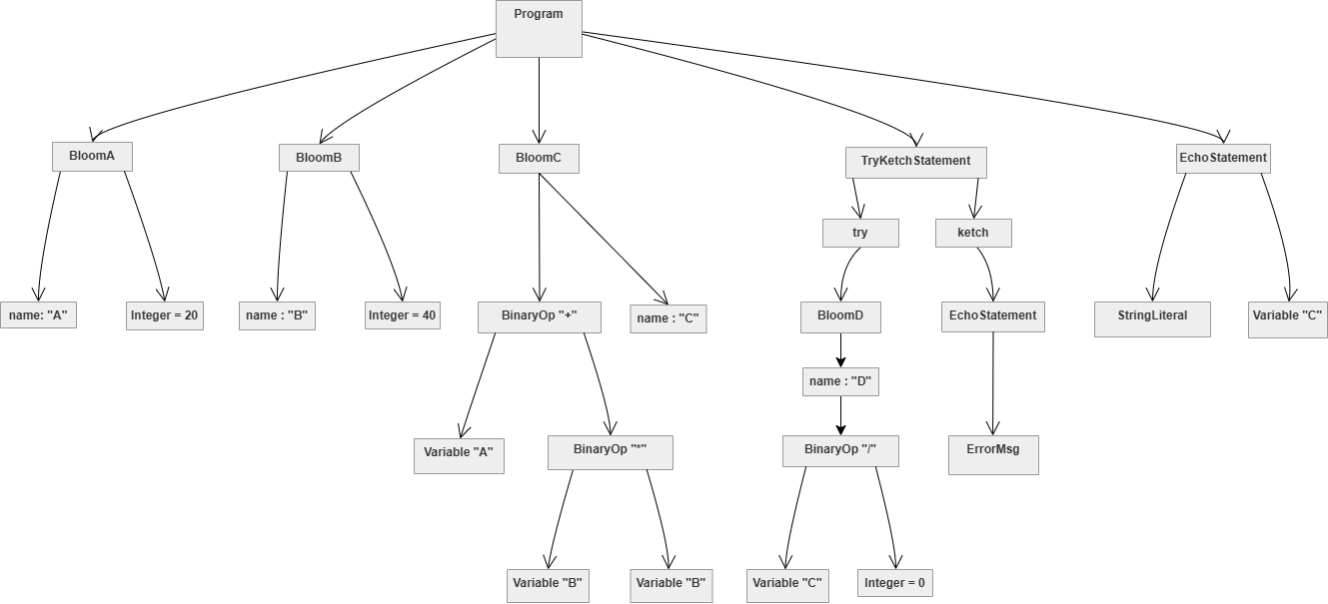
Parse Tree:

Key observations: The BloomStatement for C correctly nests the '+' operator above the '*' operator in the tree, enforcing PEMDAS — C = A + (B * B) = 20 + 1600 = 1620. The TryKetchStatement contains two child blocks. The EchoStatement at the end holds multiple expressions.

7.2 Function with Conditional — Parse Tree
Source code:
craft max(a, b) {
when (a > b) {
return a;
} otherwise {
return b;
}
}
Parse Tree:
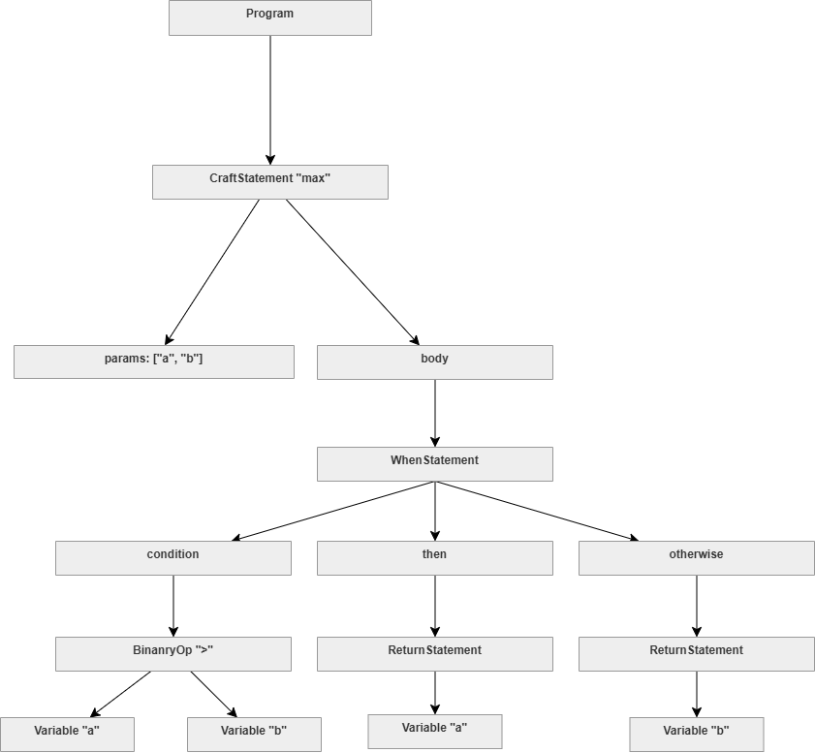

8. Scope and Binding

8.1 Scope Rules
Sarana implements lexical (static) scoping. There are three scope levels:
- Global scope — variables declared at the top level of a program are accessible from anywhere in the program.
- Function scope — variables declared inside a craft block are local to that function and inaccessible outside it.
- Block scope — variables declared inside a when or cycle block are local to that block.

8.2 Binding
Sarana uses early binding for variables (names are bound to values at the point of declaration using bloom) and static binding for function names (a craft statement binds the function name to its body at definition time). There is no implicit hoisting, a variable must be declared before it is used, or a Semantic Error is raised.

8.3 Scope and Binding — Sample Code
The following sample (sample2.sa) demonstrates all scope levels:
-- Global scope
bloom x = 100;
bloom greeting = "Hello from Sarana";
echo greeting;

-- Block scope: y is local to this when block
when (x > 50) {
bloom y = x * 2;
echo "Inside block, y = " y;
echo "Inside block, x = " x; -- x visible here (global)
}
-- y is NOT accessible here (block scope ended)
echo "Outside block, x = " x;

-- Function scope
craft greet(name) {
bloom message = "Welcome, " + name;
echo message;
return message;
}
bloom result = greet("Alice");

-- Nested scopes
bloom outer = 10;
craft testScope() {
bloom inner = 20;
echo "Inside function: outer = " outer; -- global accessible
echo "Inside function: inner = " inner; -- local
when (outer > 5) {
bloom nested = 30;
echo "Inside when block: nested = " nested;
}
return inner + outer;
}
bloom total = testScope();
echo "Final total: " total;
In this program, x and greeting are global. y is block-scoped inside the when block and would cause a SemanticError if referenced after the closing brace. message and inner are function-scoped within their respective craft definitions. nested is block-scoped inside the when block within testScope.

9. Implementation Language
Sarana's compiler was developed in Python 3, using the PLY library (Python Lex-Yacc) for lexical and syntactic analysis.

9.1 Why Python and PLY?
- Python 3 is expressive, readable, and widely taught, making the implementation accessible to the entire group.
- PLY closely mirrors the classic LEX/YACC toolchain studied in CIT4004, providing a direct mapping between course theory and implementation practice.
- PLY's lex module handles tokenization using Python regular expressions; PLY's yacc module handles LALR(1) parsing and AST construction.
- Python's dynamic typing and first-class functions simplify AST node representation and tree-walking interpretation.

9.2 Compiler Pipeline
The Sarana compiler implements the following phases:
- Lexical Analysis — PLY lex tokenizes the source into the token stream.
- Syntax Analysis — PLY yacc parses the token stream against the EBNF grammar and builds an AST.
- Semantic Analysis — A tree-walking analyzer checks variable declarations, function definitions, and type compatibility.
- Code Generation / Interpretation — The AST is walked by an interpreter that evaluates expressions and executes statements, or optionally transpiles to Python.
- LLM Comparison — The same source program is sent to a Large Language Model (e.g., Google Gemini or OpenAI GPT) via API; both outputs are displayed side by side.

10. Error Handling
Sarana defines five distinct error classes, each raised at a specific phase of compilation or execution:
Error Class | When It Occurs
Lex Error | Unrecognized character in source code
Parse Error | Source code violates grammar rules
Semantic Error | Variable used before bloom, or function called before craft
Sarana Runtime Error | Runtime error such as division by zero or type mismatch
Unexpected End Error | Program ends unexpectedly e.g., unclosed block

All errors produce a descriptive message including the line number and the offending token or construct, so that the programmer can quickly locate and fix the problem.

11. Complete Sample Programs

11.1 Required Assignment Sample
-- Required assignment sample program
bloom A = 20;
bloom B = 40;
bloom C = A + B * B; -- PEMDAS: 20 + (40 * 40) = 1620

-- Demonstrating Exception Handling
try {
bloom D = C / 0;
}
ketch {
echo "Error: Division by zero attempted but not allowed.";
}
echo "The result is " C;

Expected output:
Error: Division by zero attempted but not allowed.
The result is 1620

11.2 Functions and Loops
craft multiply(a, b) {
bloom product = 0;
bloom count = 0;
cycle (count < b) {
bloom product = product + a;
bloom count = count + 1;
}
return product;
}
bloom result = multiply(6, 7);
echo "6 * 7 = " result;

Expected output:
6 * 7 = 42

11.3 Boolean Logic and Short-Circuit Evaluation
bloom x = 10;
-- Short-circuit: x > 5 is true, so x / 0 is never evaluated
when (x > 5 or x / 0 > 1) {
echo "Short-circuit OR works!";
}
bloom score = 95;
when (score >= 90) {
echo "A (with bonus)";
} otherwise when (score >= 80) {
echo "B";
} otherwise {
echo "Below B";
}

12. LLM Integration and Comparison
As required by the project brief, Sarana includes integration with a Large Language Model to simulate execution of the same source program. The application sends the Sarana source code to the LLM API (Google Gemini) and records the response, displaying the deterministic compiler output alongside the LLM's probabilistic output for direct comparison.

12.1 Purpose of the Comparison
- To demonstrate the difference between deterministic compilation (always produces the same output for the same input) and probabilistic LLM interpretation (may produce varying or incorrect results).
- To highlight that a formal compiler enforces grammar rules strictly, while an LLM may guess at intent.
- To satisfy Learning Objective 7 of the project: compare results from formal compilation vs probabilistic execution.

12.2 Expected Findings
For simple arithmetic and output programs, the LLM is likely to produce the correct result. However, for programs that test strict operator precedence, scope rules, or exception handling semantics, the deterministic compiler will consistently produce the formally correct result while the LLM may produce an approximation or incorrect answer.

13. Conclusion
Sarana is a formally designed, deterministically compiled, high-level general-purpose programming language that demonstrates all nine characteristics of a good programming language as defined in CIT4004. Its Caribbean-inspired keywords make it culturally distinctive and highly readable, while its underlying grammar, lexer, parser, semantic analyzer, and interpreter are grounded in formal language theory.
The language supports arithmetic with correct PEMDAS/BODMAS precedence, typed variables, string output, conditional branching, loops, functions, arrays, Boolean logic with short-circuit evaluation, and robust exception handling via try/ketch. The compiler is implemented in Python 3 using PLY, and the application integrates with a Large Language Model for comparative execution analysis

References

Hubert, B. (n.d.). Lex and YACC primer/HOWTO. https://tldp.org/HOWTO/Lex-YACC HOWTO.html
Beazley, D. M. (n.d.). PLY (Python Lex-Yacc). https://www.dabeaz.com/ply/ply.html
Debray, S. K. (n.d.). Lex and Yacc: A brisk tutorial. University of Arizona. https://www2.cs.arizona.edu/~debray/Teaching/CSc453/DOCS/tutorial-large.pdf
Google DeepMind. (n.d.). Google Gemini. https://deepmind.google/technologies/gemini/
Sebesta, R. W. (2016). Concepts of programming languages (11th ed.). Pearson.

